<https://github.com/boboppie/coursera-course-statistics_one>

**LECTURE 11– Moderation**

Mediation vs moderation:

* X predictor variable (independent variable - IV)
* Y outcome variable (dependent variable – DV)
* Mediation (M): look at 2 variables, find M that mediates the correlation
  + Mediation variable - M
* Moderation (Z): influence and control on the relationships
  + Moderator variable - Z

**Segment 1: Moderation example 1**

Moderation: new variable that could influence and vary the relationships

X,Y are the variables. We add a Z moderator variable.

* Y = B0 + B1X +e 🡨 simple regression (X🡪Y)
  + B1 will depend on Z

**Y = B0 + B1M + B2Z + B3(X*Z) + e**

Example:

X: working memory capacity / Y: SAT / Z: Type of University

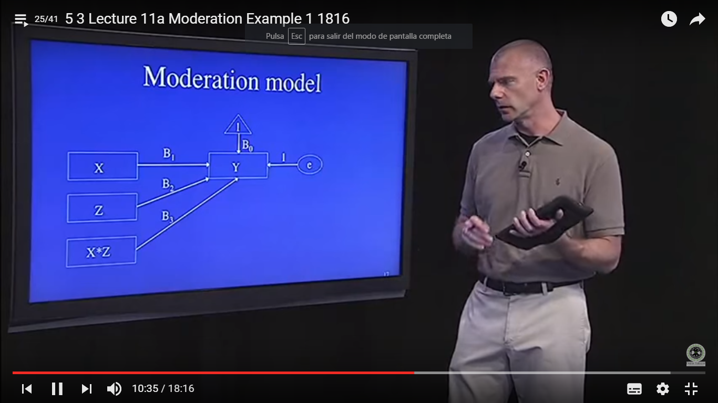

Implement moderation in R:

* lm (Y ~X+Z +X*Z)

X is extra, Y is happy. X*Z is the product term (moderation).

**Segment 2: Centering and dummy coding**

* Centering predictors:
  + Center means to put in deviation form. Mean to be 0.
  + Xc = X-M
* Conceptual:
  + helps to provide with regression coefficients that are easier to interpret and that are more meaningful
* Statistical:
  + Avoid multi-colinearility. Happens when X1 and X2 are highly correlated with the product X1 *X2

Steps:

* Center predictors
* Run sequential analysis:
  + Main effects
  + Moderation effects
    - Evaluate B for the Product (X*Z)
    - Evaluate R2 variance from Model 1 to Model 2

Dummy Coding:

* Choose a category as reference group. We have 4 categories to create the simple dummy coding scheme.
* Add to data file (C1, C2, C3)

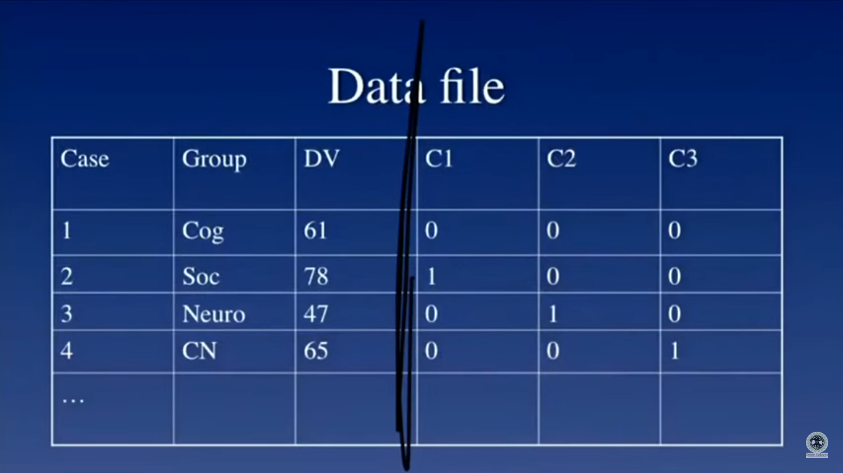

* Run a regression analysis with C1, c2, c3
  + **^Y = B0 + B1(C1) + B2(C2) + B3(C3)**
* To have exact results, use weighted effects coding:

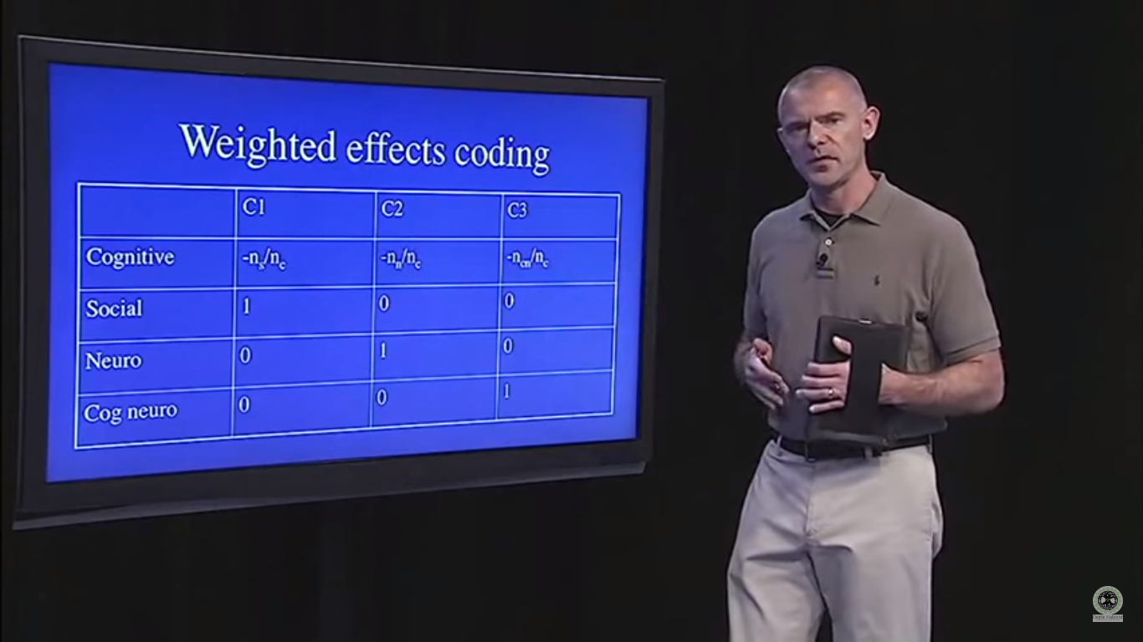

**Segment 3: Moderation example 2**

* Does department moderates the relationship between nº publications and salaty?

